Updates required

1. When you first run the .exe file you can only see first five results from the robot.txt file. If there are more then 5 entries they would not be shown.

If there are less then 5 entries, it shows weird numbers

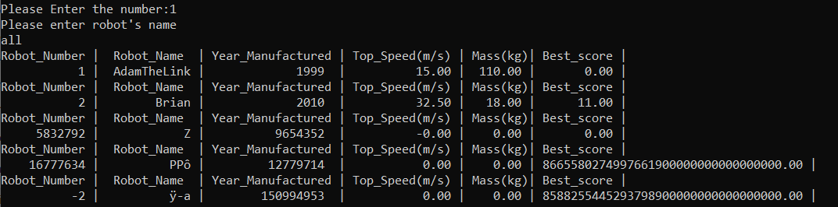

In this screenshot you can see, I only had two entries in robot.txt file and it auto-generated these weird numbers. Please fix this issue, it should show all the entries in txt file. When you run the .exe file without robot.txt file it generates these weird numbers as well.

1. In the above screenshot you can see every entry has a header, there should be only one header and all the entries should come in line rather then using individual heading for every line printed.
2. Apparently, you have not yet defined structure of Result_t to store your simulation results – without saving your simulation result in an array of Result_t, it is impossible to do Menu item 4, 5, and 7?

Please define result_t array to store simulation results.

1. Apparently you opened two files but not closed in the same place ( or in same function) – This may cause problem in some cases, e.g., if some errors occurs during code development, making the program broken, then the opened file won’t be closed properly -As a result, the content of the file may become empty or Null due “not closed” (not sure if you have experience this case)